1. Source Code

view-form-matakuliah.php -> application/views

view-data-matakuliah.php -> application/views

Matakuliah.php -> application/controllers

1. URL

<http://localhost/pustakabooking/index.php/Matakuliah>

<http://localhost/pustakabooking/matakuliah/cetak>

1. Capture Output program

* view form matakuliah

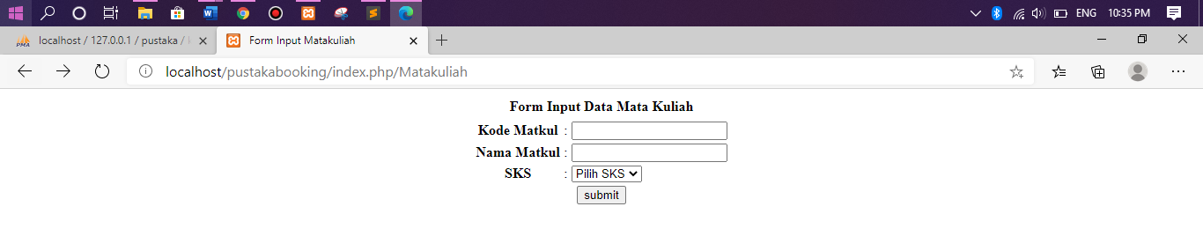

* data matakuliah

